LAB asseSSment 1 (LA1) soft-record
BCSE203E: Web Programming Lab
Programme: B.Tech ; Branch: CSE
Class number: VL2025260504864;
Slot: L33+L34/L59+L60
Time: 15:51 – 17:30/17:40 – 19:20
VENUE: PRP232

Reg No: 24BCE2195
Name: vINAYAK NAUTIYAL


School of Computer Science and Engineering

Assessment:  Date: | Problem Statement-1
Write an HTML program that displays a main heading and a paragraph.
The page must include the correct HTML structure with
  - <!DOCTYPE html>,
  - <html>,
  - <head>, <title>, and <body>
Program | <!DOCTYPE html>  <html>  <head>  <title>  Welcome to My Website  </title>  </head>  <body>  <p>This is a welcome page to my first website html page that i've implemented.</p>  </body>  </html>
Output Screenshots | 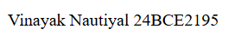  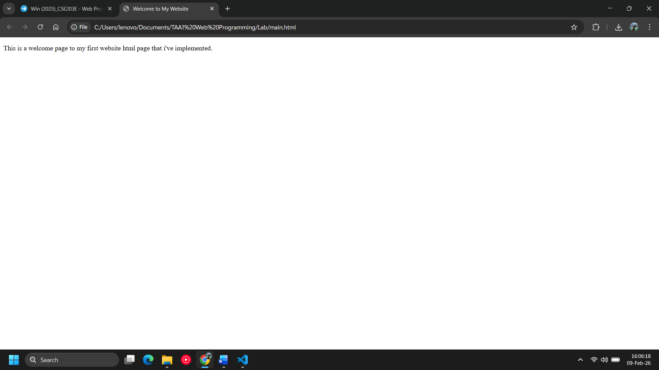
Observations | This program shows the basic structure of an HTML document.
References

Assessment:  Date: | Problem Statement-2
Write an HTML program that uses five different HTML tags.
- The program must include:
- One heading
- One paragraph
- One image
- One hyperlink
- One unordered list
- (with at least two items)
Program | <!DOCTYPE html>  <html>  <head>  <title>HTML Tags</title>  </head>  <body>  <h1>HTML Example</h1>  <p>This is a paragraph.</p>  <img src="Resources/images.jpg">  <a href="https://www.google.com">Visit Google</a>  <ul>  <li>HTML</li>  <li>CSS</li>  </ul>  </body>  </html>
Output Screenshots | 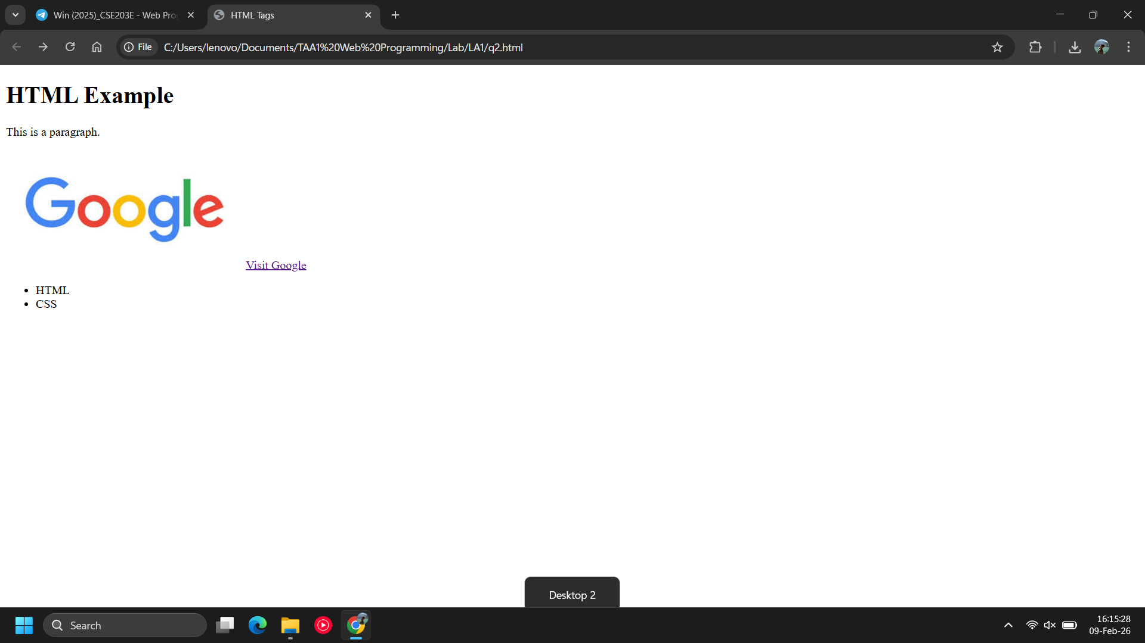
Observations | Different HTML tags are used in this program.
References

Assessment:  Date: | Problem Statement-3
Write an HTML program that uses at least three block elements.
Use <div>, <p>, and any one heading tag.
Display a heading inside a division and add two paragraphs below it."
Program | <!DOCTYPE html>  <html>  <head>  <title>Block Elements</title>  </head>  <body>  <div>  <h2>Block Elements</h2>  <p>This is first paragraph.</p>  <p>This is second paragraph.</p>  </div>  </body>  </html>
Output Screenshots | 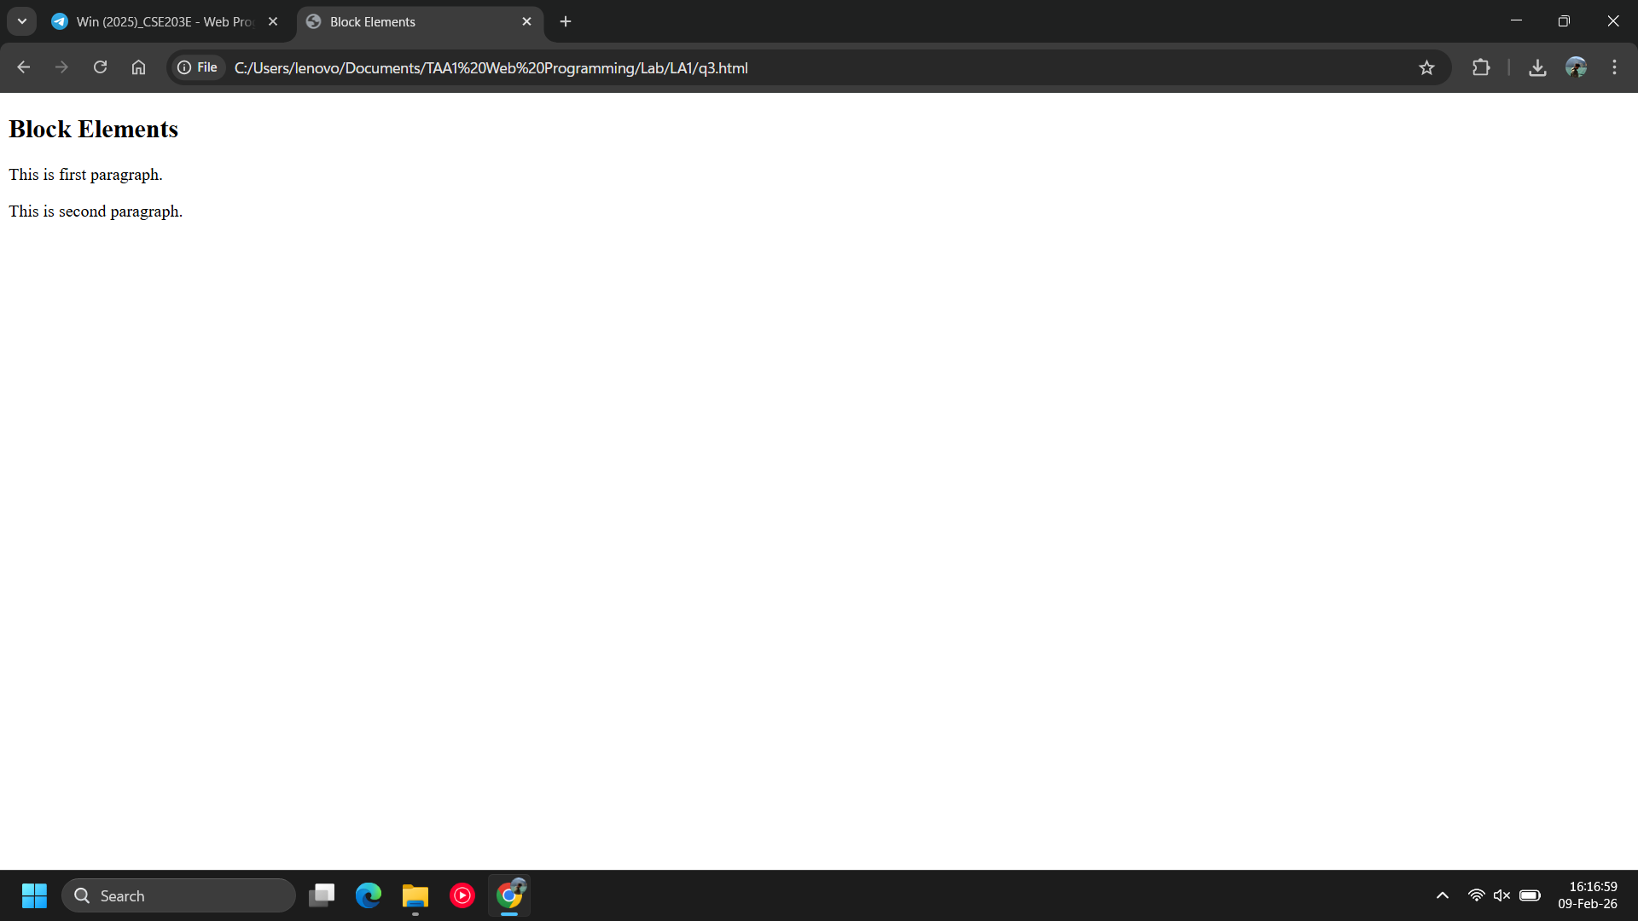
Observations | Block-level elements like div, p, and heading are used.
References

Assessment:  Date: | Problem Statement-4
Write an HTML program using the following text formatting tags:<b>, <i>, <u>, <em>, <strong>.
Create one sentence for each tag showing its effect.
Program | <!DOCTYPE html>  <html>  <head>  <title>Text Formatting</title>  </head>  <body>  <p><b>This is bold text.</b></p>  <p><i>This is italic text.</i></p>  <p><u>This is underlined text.</u></p>  <p><em>This is emphasized text.</em></p>  <p><strong>This is strong text.</strong></p>  </body>  </html>
Output Screenshots | 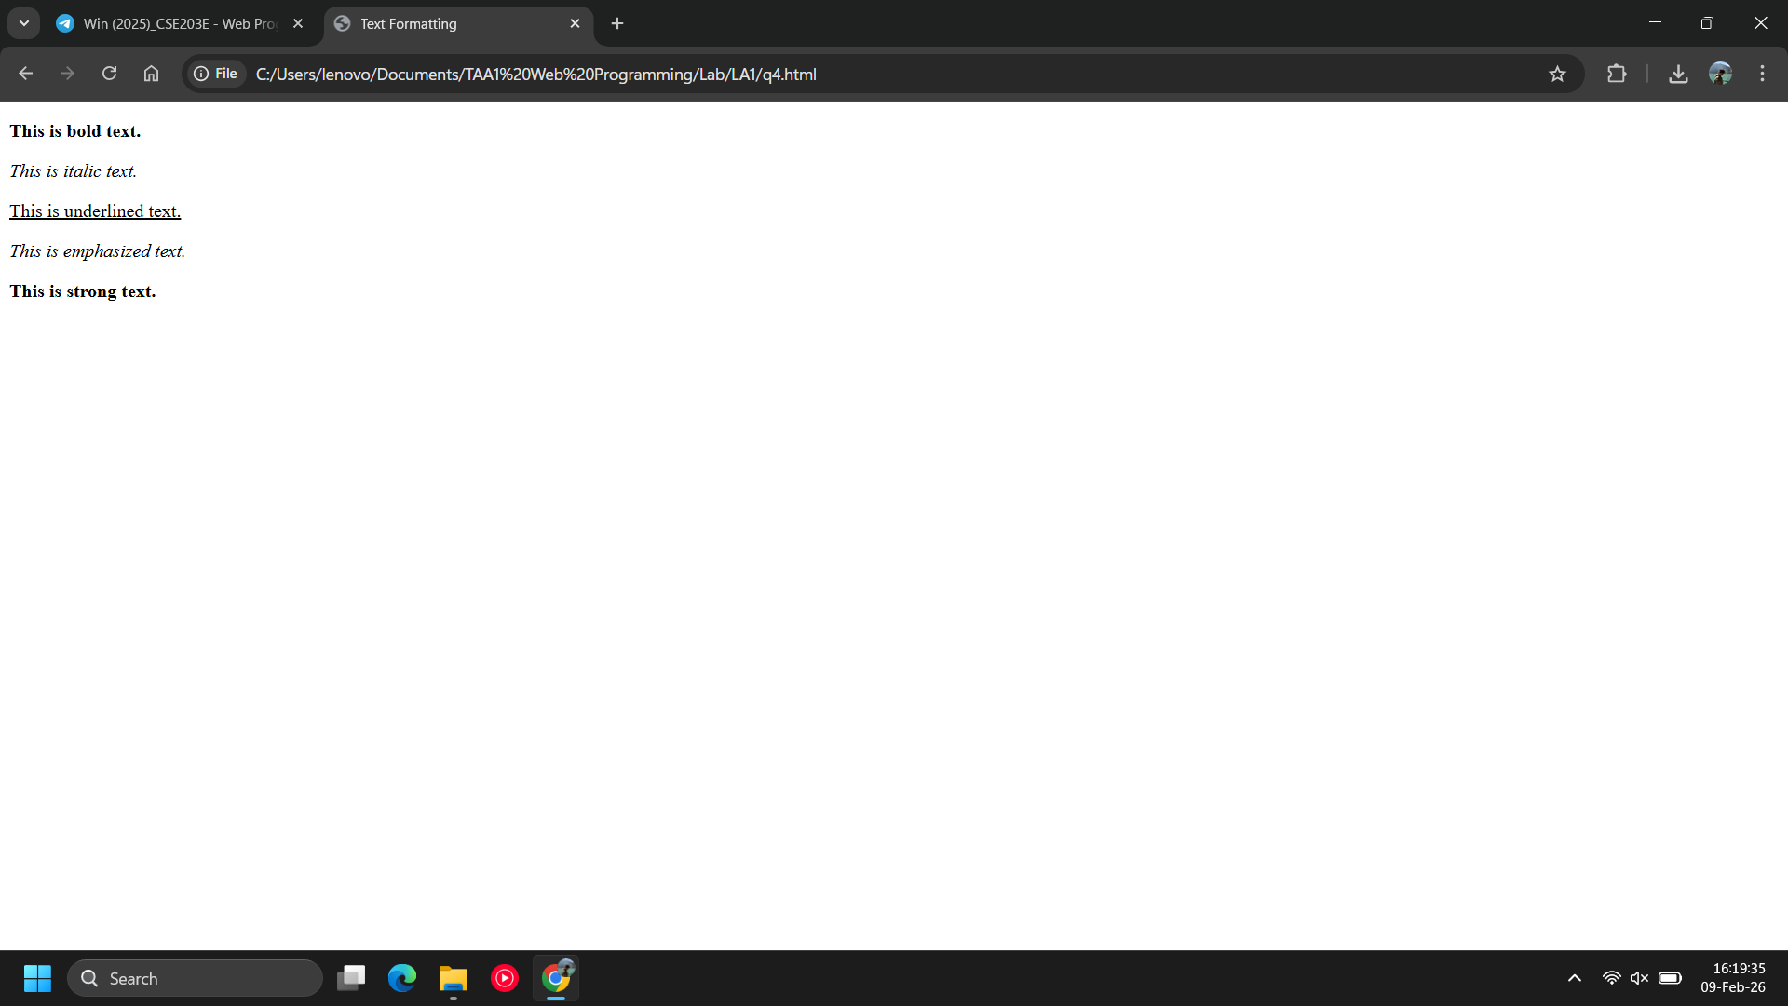
Observations | Text formatting tags are demonstrated in this program.
References

Assessment:  Date: | Problem Statement-5
 | Write an HTML program that displays a paragraph with two line breaks using <br>.Below the paragraph insert a horizontal line using <hr>.Write another paragraph after the line."
Program | <!DOCTYPE html>  <html>  <head>  <title>Line Breaks</title>  </head>  <body>  <p>  This is first line.<br>  This is second line.<br>  This is third line.  </p>  <hr>  <p>This paragraph appears after horizontal line.</p>  </body>  </html>
Output Screenshots | 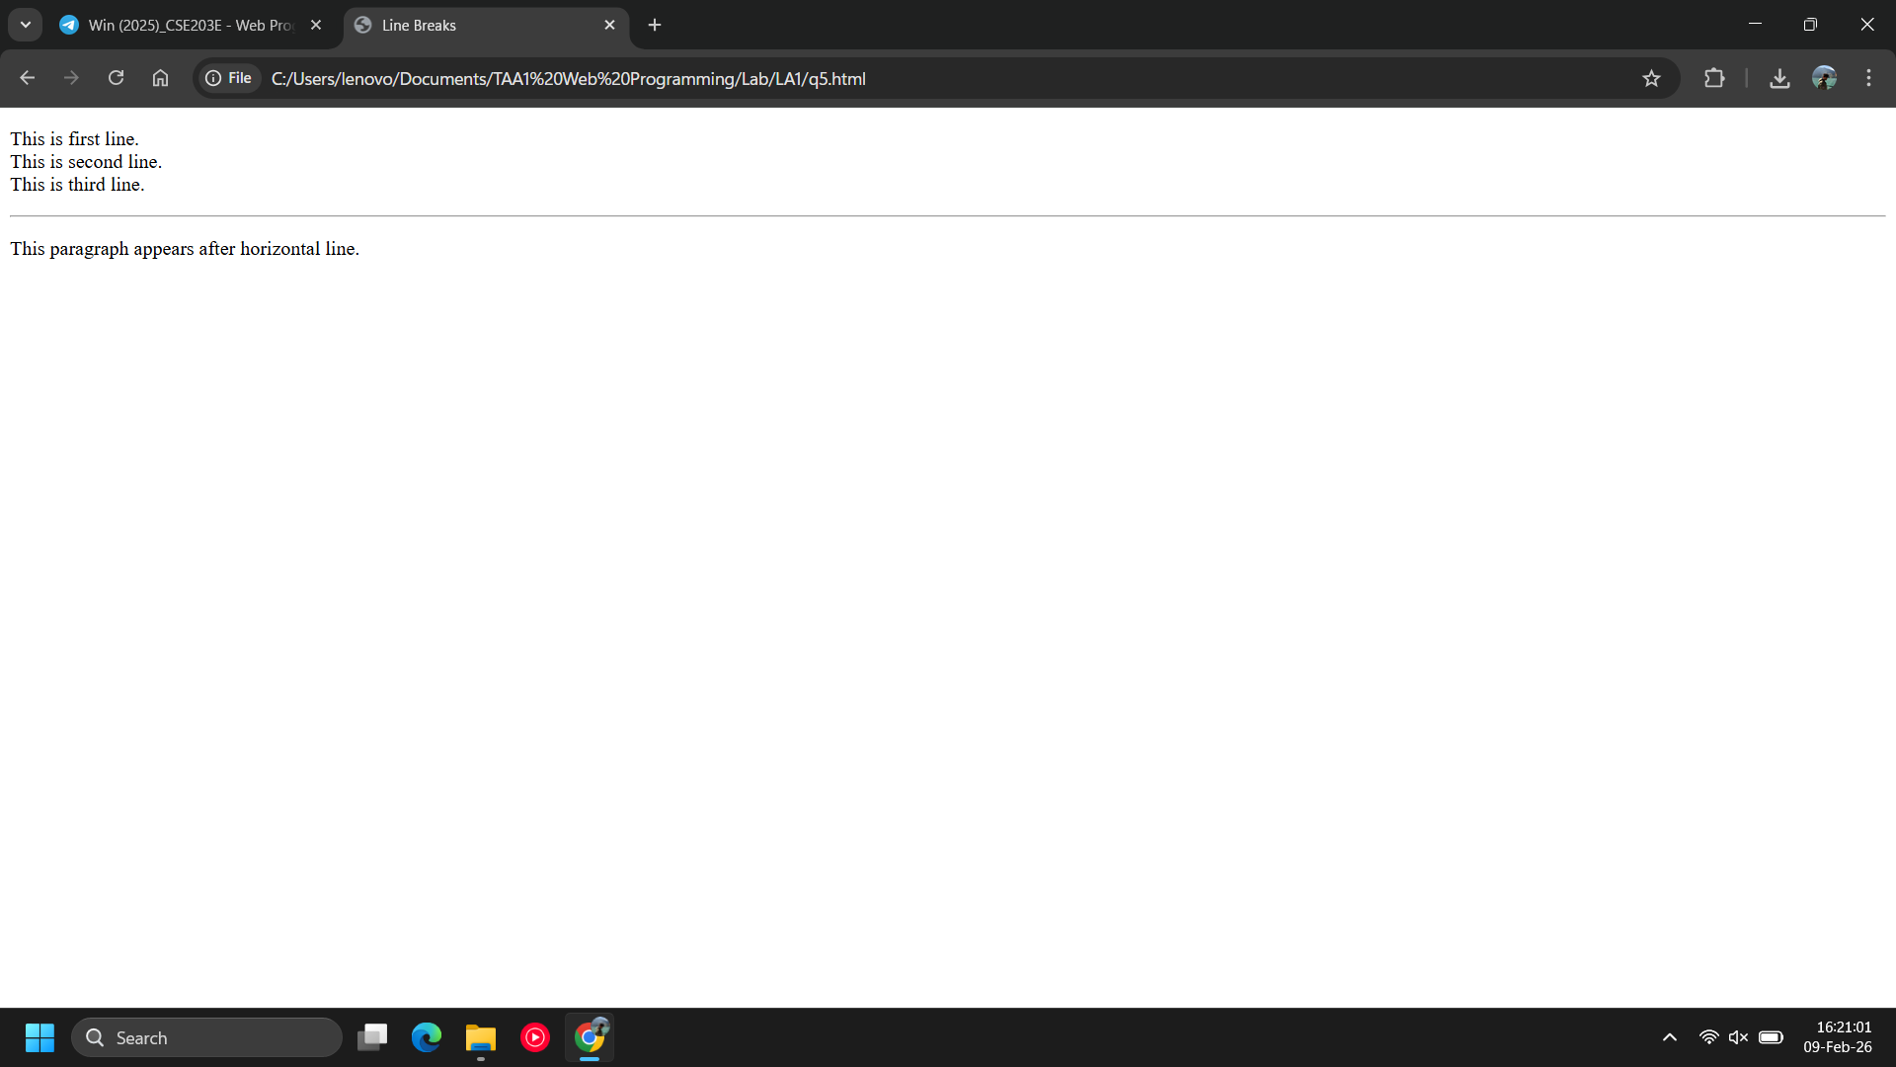
Observations | A paragraph is displayed with 2 line breaks using <br> and a horizontal line using <hr>.
References

Assessment:  Date: | Problem Statement-6
 | Write an HTML program that uses a <div> containing a heading and a paragraph. Inside the paragraph, bold one word and italicize another.
Program | <!DOCTYPE html>  <html>  <head>  <title>Div Example</title>  </head>  <body>  <div>  <h2>HTML Div</h2>  <p>This is <b>bold</b> and this is <i>italic</i>.</p>  </div>  </body>  </html>
Output Screenshots | 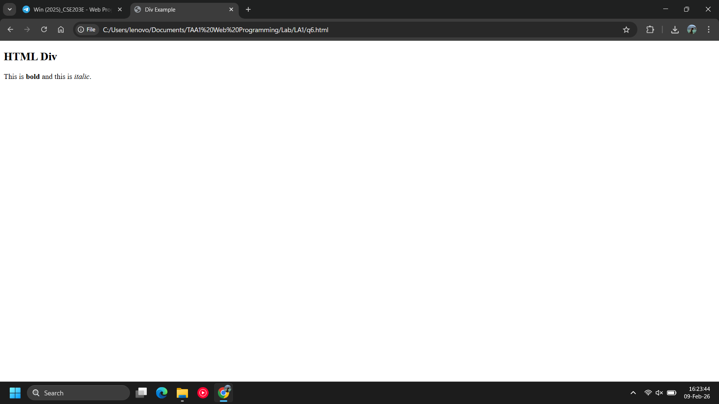
Observations | Created a paragraph which has a bold word and italic word.
References

Assessment:  Date: | Problem Statement-7
A Tech Learning Hub wants a basic webpage that introduces their center to new learners.
They want the webpage to include the following items:
Required Content for the Webpage
- A main heading titled “Tech Learning Hub”.
- A short introduction paragraph describing what the hub offers.
- An image that represents learning or technology.
- A navigation link labeled “Enroll Now” that opens the enrollment page.
- A list of three courses offered by the hub.
- One bold text sentence and one italic text sentence that highlight important information.
- A separate information box (using a <div> tag) titled “Announcements” with two announcements inside it.
- A footer stating “© 2025 Tech Learning Hub”.
Students must create one single HTML file that includes all the above requirements.

Program | <!DOCTYPE html>  <html>  <head>  <title>Tech Learning Hub</title>  </head>  <body>  <h1>Tech Learning Hub</h1>  <p>Tech Learning Hub provides quality technical education.</p>  <img src="Resources/tech.jpg" width="300">  <br><br>  <a href="enroll.html">Enroll Now</a>  <h3>Courses Offered</h3>  <ul>  <li>Web Development</li>  <li>Python Programming</li>  <li>Data Science</li>  </ul>  <p><b>Admissions are open now!</b></p>  <p><i>Limited seats available.</i></p>  <div>  <h3>Announcements</h3>  <p>New batch starts soon.</p>  <p>Scholarships available.</p>  </div>  <footer>  © 2025 Tech Learning Hub  </footer>  </body>  </html>
Output Screenshots | 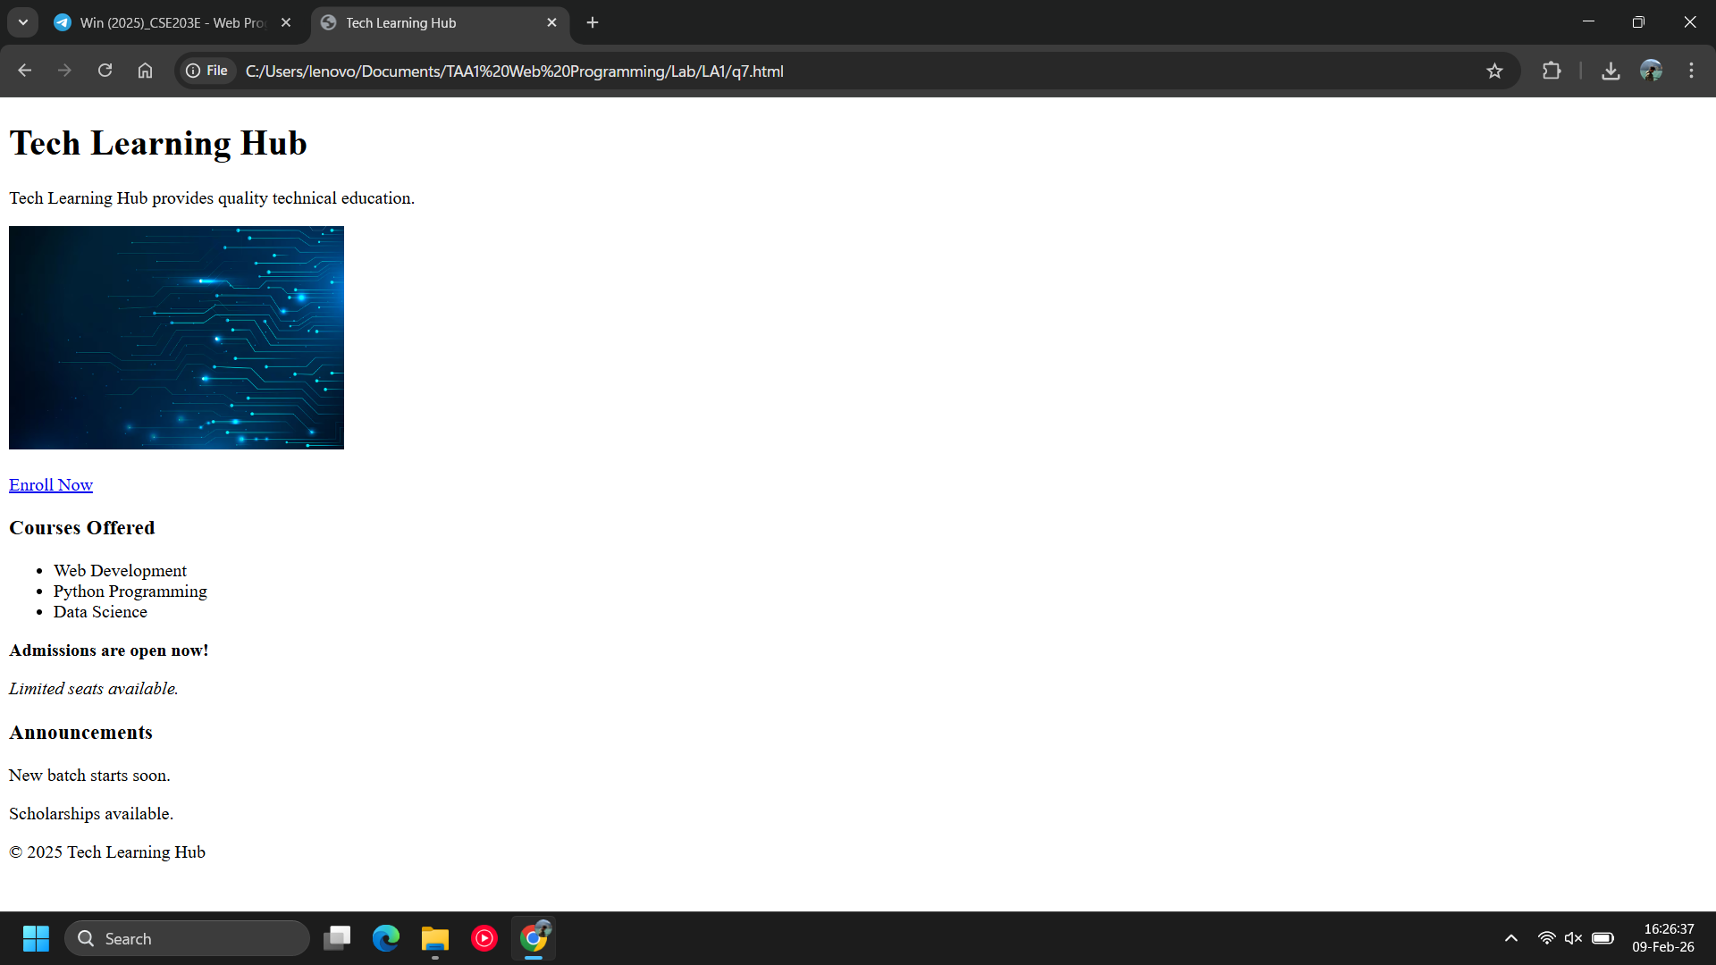
Observations | Created a webpage that has a footer, an image, a link, heading, short paragraph, and various other details like a list, an announcements column using div.
References

Assessment:  Date: | Problem Statement-8
Create an HTML page that uses one <section> element to explain student eligibility rules for an internal assessment.
Inside the section:
- Write a paragraph that explains the following conditions in sentence form:
  - Attendance is greater than 75%
  - Assignment count is less than 5
  - Internal score is less than or equal to 40
- All comparison symbols must be displayed correctly using HTML character references.
Program | <!DOCTYPE html>  <html>  <head>  <title>Eligibility Rules</title>  </head>  <body>  <section>  <p>  Attendance must be greater than 75% (&gt; 75%).<br>  Assignment count must be less than 5 (&lt; 5).<br>  Internal score must be less than or equal to 40 (&le; 40).  </p>  </section>  </body>  </html>
Output Screenshots | 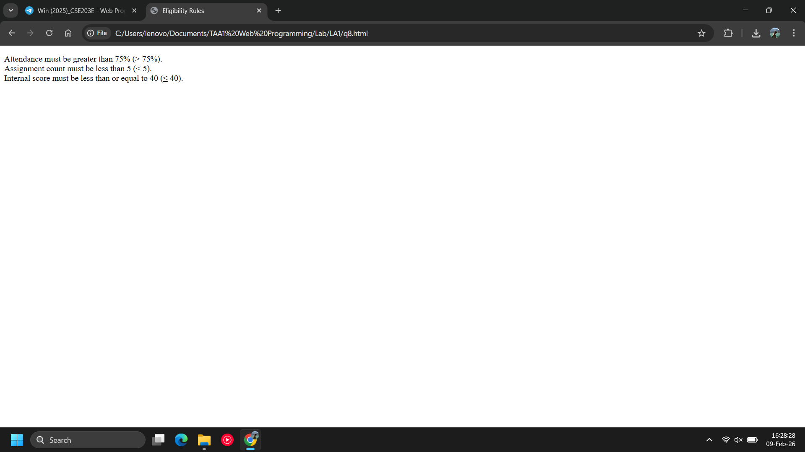
Observations | Employed use of &gt, &lt &le for symbols >, <, <= respectively.
References

Assessment:  Date: | Problem Statement-9
A Web Development Training Cell is preparing a tutorial page to explain how images can be added to a web page using different sources.
- From an external website link (URL)
- From an image stored on the local computer
- From an image placed inside the project folder
Program | <!DOCTYPE html>  <html>  <head>  <title>Images</title>  </head>  <body>  <h3>External Image</h3>  <img src="https://picsum.photos/536/354">  <h3>Local Computer Image</h3>  <img src="Resources/Local/localcomputer.png">  <h3>Project Folder Image</h3>  <img src="Resources/folderimage.jpg">  </body>  </html>
Output Screenshots | 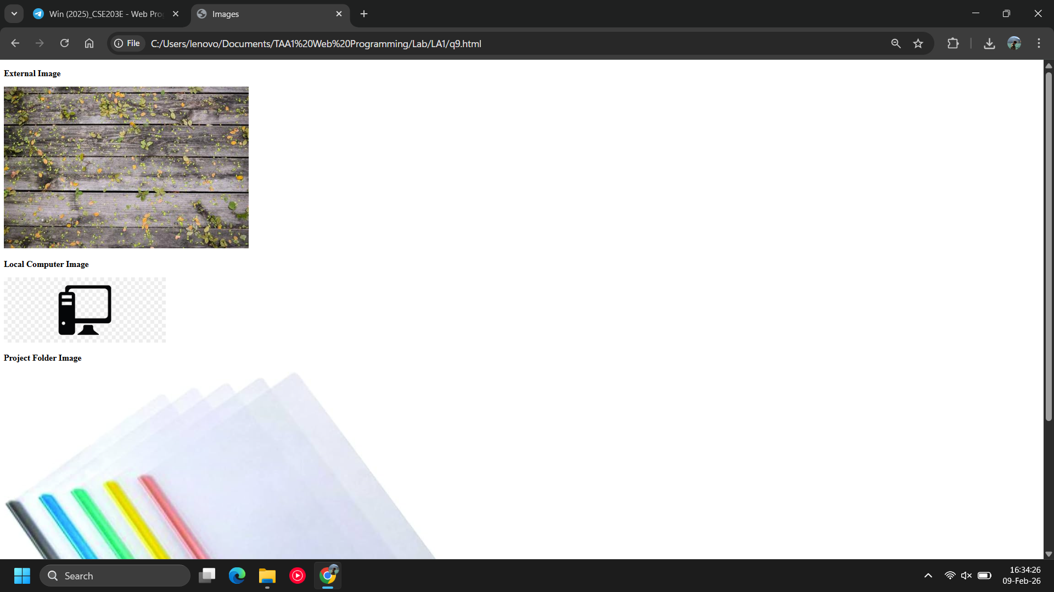
Observations | Employed use of an external image from lorem ipsum, a local computer image, and a project folder image.
References

Assessment:  Date: | Problem Statement-10
Create the following table in HTML with Dummy Data:
- Use <table> ….. </table> tag to draw table
- Create 3 rows in the table by using <tr>…. </tr>
- In the first row create table heading by using <th>….</th> tag
- In the next 2 rows add the data by using <td>….</td> tag
- Move the table to the center
- <table border= "1" align="center">
- Add color to the 1st row and make it bold
- <tr style="background-color: lightgreen; font-weight: bold;">
Program | <!DOCTYPE html>  <html>  <head>  <title>Table</title>  </head>  <body>  <table border="1" align="center">  <tr style="background-color: lightgreen; font-weight: bold;">  <th>ID</th>  <th>Name</th>  <th>Course</th>  </tr>  <tr>  <td>1</td>  <td>Rahul</td>  <td>HTML</td>  </tr>  <tr>  <td>2</td>  <td>Anita</td>  <td>CSS</td>  </tr>  </table>  </body>  </html>
Output Screenshots | 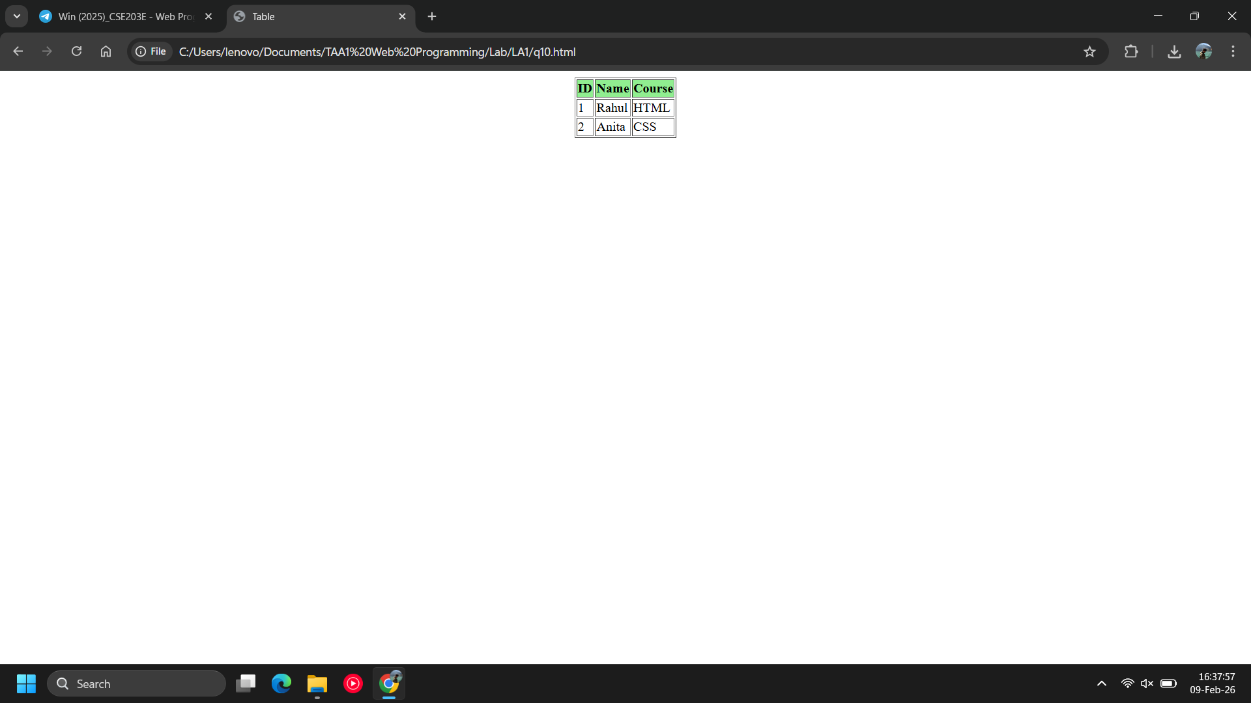
Observations | Created a table using tr, th, and td tags to create the table, rows etc. Gave it color, used font bold, gave it border too.
References

Assessment:  Date: | Problem Statement-11
A student intends to design a personal portfolio website using HTML Frames so that personal information, portfolio content, and profile details are displayed simultaneously on a single screen.
- The webpage must be divided into three frames using the <frameset> tag.
Task Requirements
- Create an HTML file named main-frame.html.
- Use the <frameset> tag instead of the <body> tag.
- Divide the webpage layout as follows:
  - Two columns:
    - Left column → 20% width
    - Right column → 80% width
  - The right column must be divided into two rows:
    - Top row → 60% height
    - Bottom row → 40% height
- Load the following files into the respective frames:
  - Left frame → left-frame.html
  - Right top frame → right-top-frame.html
  - Right bottom frame → right-bottom-frame.html
Content Specifications for Each Frame
1️⃣ left-frame.html – Personal Details and Skills
This frame displays basic personal and professional information.
The page must include:
- A student profile image
- Contact details:
  - Gmail ID
  - GitHub profile link
  - LinkedIn profile link
  - Phone number
  - Address
- A heading titled “Skills”, followed by a brief description in one line for each technical skills
- A heading titled “Personality Traits”, followed by a bullet points describing personal qualities

2️⃣ right-top-frame.html – Portfolio Content
This frame displays the main portfolio information.
The page must include:
- Student name as the main heading
- A short paragraph describing the student
- Education details
- Projects (project title with brief description)
- Activities and Achievements
- Hobbies
- Languages Known

3️⃣ right-bottom-frame.html – Personal Profile and Declaration
This frame displays personal profile information.
The page must include a heading titled “Personal Profile” and contain:
- Name
- Father’s Name
- Mother’s Name
- Date of Birth
- Gender
- Nationality
Below the profile details, include a Declaration statement confirming that the information provided is true and correct.

Program | Q11.html:  <!DOCTYPE html>  <html>  <head>  <title>Main Frame</title>  </head>  <frameset cols="20%,80%">  <frame src="q11/left-frame.html">  <frameset rows="60%,40%">  <frame src="q11/right-bottom-frame.html">  <frame src="q11/right-top-frame.html">  </frameset>  </frameset>  </html>  Left-frame.html:  <!DOCTYPE html>  <html>  <head>  <title>Left Frame</title>  </head>  <body>  <img src="../Resources/profile.jpg" width="150" height="150">  <p>Email: vinayak.nautiyal2024@vitstudent.ac.in</p>  <p>GitHub: https://github.com/vinayak</p>  <p>LinkedIn: https://linkedin.com/vinayak</p>  <p>Phone: 9729406887</p>  <p>Address: Vellore, India</p>  <h3>Skills</h3>  <p>HTML – Web page structure</p>  <p>CSS – Page styling</p>  <p>JavaScript – Basic scripting</p>  <h3>Personality Traits</h3>  <ul>  <li>Hardworking</li>  <li>Quick Learner</li>  <li>Team Player</li>  </ul>  </body>  </html>  Right-frame-top.html:  <!DOCTYPE html>  <html>  <head>  <title>Portfolio</title>  </head>  <body>  <h1>Vinayak Nautiyal</h1>  <p>I am a B.Tech CSE student interested in web development.</p>  <h3>Education</h3>  <p>B.Tech – Computer Science and Engineering</p>  <h3>Projects</h3>  <p>Student Portfolio Website</p>  <p>Simple HTML Web Pages</p>  <h3>Activities and Achievements</h3>  <p>Participated in coding events</p>  <h3>Hobbies</h3>  <p>Reading, Coding, Gaming</p>  <h3>Languages Known</h3>  <p>English, Hindi, Punjabi</p>  </body>  </html>  Right-bottom-frame.html:  <!DOCTYPE html>  <html>  <head>  <title>Personal Profile</title>  </head>  <body>  <h3>Personal Profile</h3>  <p>Name: Vinayak Nautiyal</p>  <p>Father’s Name: Mr. Nautiyal</p>  <p>Mother’s Name: Mrs. Nautiyal</p>  <p>Date of Birth: 14-12-2005</p>  <p>Gender: Male</p>  <p>Nationality: Indian</p>  <p>  Declaration: I hereby declare that the above information is true and correct.  </p>  </body>  </html>
Output Screenshots | 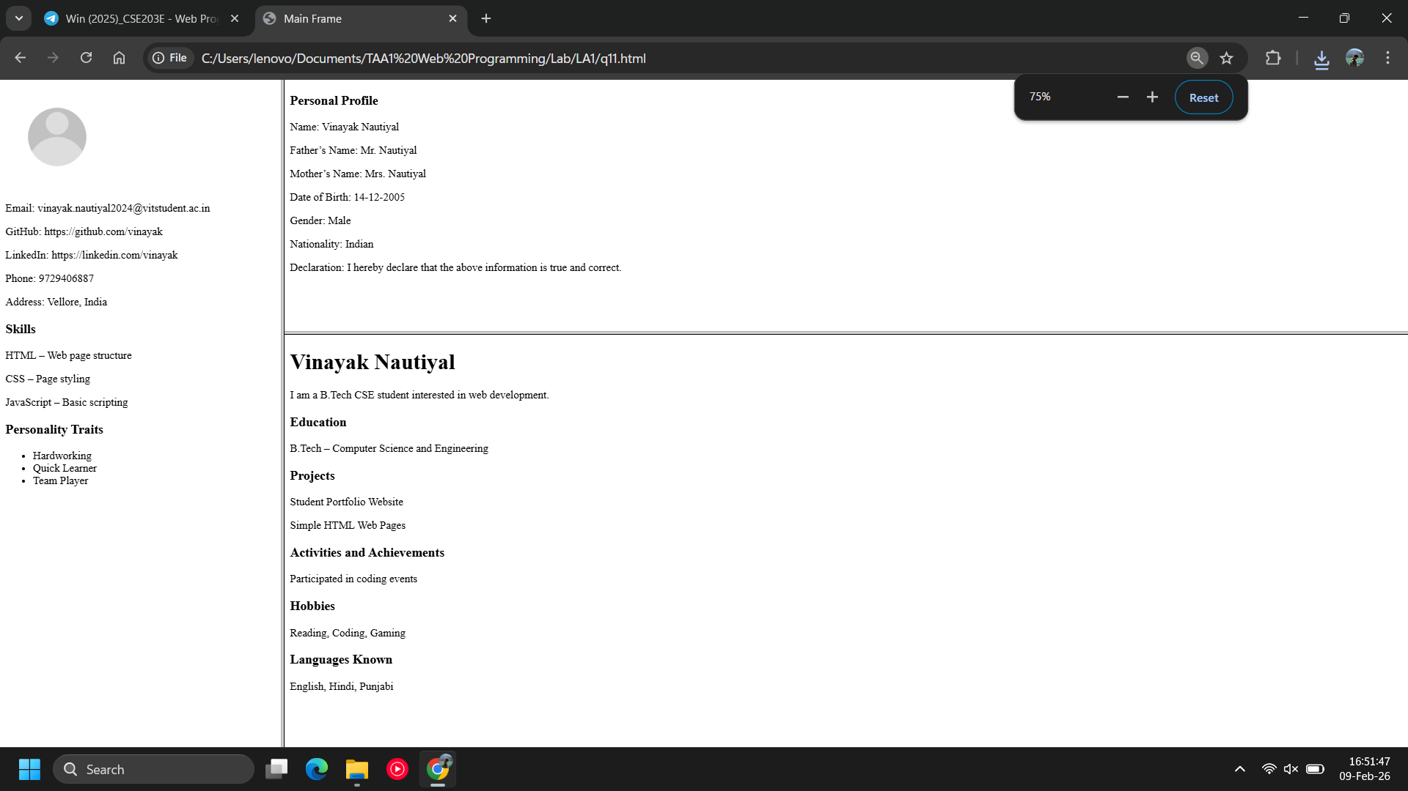
Observations | Employed use of frames to generate a webpage with 3 sections-Personal Details, Portfolio, Personal Profile.
References

Assessment:  Date: | Problem Statement-12
The Health and Safety Department plans to create a web page that displays Emergency Helpline Numbers in India in a structured and user-friendly format.
Students are required to design an HTML page that presents 5 to 10 emergency helpline services (such as medical, police, fire, women safety, child safety, disaster management, etc.) using tables and images, similar to the format shown.
Requirements:
- Create an HTML page titled “Emergency Helpline Numbers in India”.
- Use a table layout for each emergency service.
- Each table must include:
  - A heading with the name of the emergency service.
  - An image/icon representing the service (for example, ambulance for medical emergency).
  - A description explaining the purpose of the helpline.
  - The helpline phone number.
  - The official email ID.
- At least 10 emergency helpline services must be included (maximum 25).
- Use proper HTML tags such as:
  - <table>, <tr>, <th>, <td>
  - <img>
  - <h2> or <caption>
Ensure the content is neatly aligned and readable.
Program | <!DOCTYPE html>  <html>  <head>  <title>Emergency Helpline Numbers in India</title>  </head>  <body>  <h1 align="center">Emergency Helpline Numbers in India</h1>  <!-- ================= MEDICAL EMERGENCY ================= -->  <table border="1" width="90%" align="center" cellpadding="10">  <tr>  <th colspan="2">Medical Emergency Helpline Numbers</th>  </tr>  <tr>  <td width="30%" align="center">  <img src="Resources/ambulance.jpg" width="120">  </td>  <td>  <table border="1" width="100%" cellpadding="8">  <tr>  <td colspan="2">  <b>Description:</b>  A medical emergency helpline is a 24x7 service that provides immediate assistance during health emergencies. It connects individuals to trained medical professionals for quick guidance, ambulance support, and coordination with hospitals.  </td>  </tr>  <tr>  <td width="40%"><b>Phone Number</b></td>  <td>108</td>  </tr>  <tr>  <td><b>Email ID</b></td>  <td>helpdesk@emri.in</td>  </tr>  </table>  </td>  </tr>  </table>  <br>  <!-- ================= POLICE EMERGENCY ================= -->  <table border="1" width="90%" align="center" cellpadding="10">  <tr>  <th colspan="2">Police Emergency Helpline Numbers</th>  </tr>  <tr>  <td width="30%" align="center">  <img src="Resources/police.png" width="120">  </td>  <td>  <table border="1" width="100%" cellpadding="8">  <tr>  <td colspan="2">  <b>Description:</b>  Police emergency helpline provides immediate assistance in cases of crime, theft, accidents, violence, and law enforcement emergencies.  </td>  </tr>  <tr>  <td width="40%"><b>Phone Number</b></td>  <td>100</td>  </tr>  <tr>  <td><b>Email ID</b></td>  <td>police@gov.in</td>  </tr>  </table>  </td>  </tr>  </table>  <br>  <!-- ================= FIRE EMERGENCY ================= -->  <table border="1" width="90%" align="center" cellpadding="10">  <tr>  <th colspan="2">Fire Emergency Helpline Numbers</th>  </tr>  <tr>  <td width="30%" align="center">  <img src="Resources/fire.jpg" width="120">  </td>  <td>  <table border="1" width="100%" cellpadding="8">  <tr>  <td colspan="2">  <b>Description:</b>  Fire emergency helpline offers quick response and rescue services during fire accidents and hazardous situations.  </td>  </tr>  <tr>  <td width="40%"><b>Phone Number</b></td>  <td>101</td>  </tr>  <tr>  <td><b>Email ID</b></td>  <td>fire@gov.in</td>  </tr>  </table>  </td>  </tr>  </table>  <br>  <!-- ================= WOMEN HELPLINE ================= -->  <table border="1" width="90%" align="center" cellpadding="10">  <tr>  <th colspan="2">Women Safety Helpline Numbers</th>  </tr>  <tr>  <td width="30%" align="center">  <img src="Resources/women.jpg" width="120">  </td>  <td>  <table border="1" width="100%" cellpadding="8">  <tr>  <td colspan="2">  <b>Description:</b>  Women safety helpline provides support and protection to women facing harassment, abuse, or emergency situations.  </td>  </tr>  <tr>  <td width="40%"><b>Phone Number</b></td>  <td>181</td>  </tr>  <tr>  <td><b>Email ID</b></td>  <td>women@gov.in</td>  </tr>  </table>  </td>  </tr>  </table>  <br>  <!-- ================= CHILD HELPLINE ================= -->  <table border="1" width="90%" align="center" cellpadding="10">  <tr>  <th colspan="2">Child Safety Helpline Numbers</th>  </tr>  <tr>  <td width="30%" align="center">  <img src="Resources/child.jpg" width="120">  </td>  <td>  <table border="1" width="100%" cellpadding="8">  <tr>  <td colspan="2">  <b>Description:</b>  Child helpline provides immediate help, care, and protection to children in distress or unsafe conditions.  </td>  </tr>  <tr>  <td width="40%"><b>Phone Number</b></td>  <td>1098</td>  </tr>  <tr>  <td><b>Email ID</b></td>  <td>child@gov.in</td>  </tr>  </table>  </td>  </tr>  </table>  </body>  </html>
Output Screenshots | 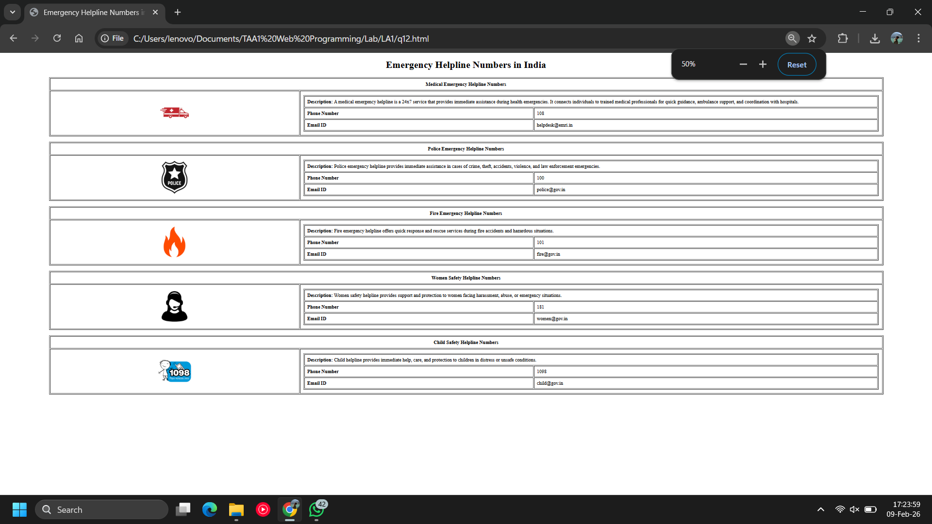
Observations | This program displays emergency helpline services in India using HTML tables.  Images and structured data make the information clear and user friendly.
References

Assessment:  Date: | Problem Statement-13
Indian Governance and State Information Portal
The Ministry of Information plans to develop an informative HTML-based web portal that presents details about India’s national leadership and state-wise information in a structured and navigable manner.
Students are required to design a multi-page HTML website to meet the following requirements.

Part A: National Leadership Page
Create a main HTML page that displays details of the current President of India and the Prime Minister of India.
President of India – Details to include:
- Name of the President
- Year from which the President was elected
- A short description (2–3 lines) about the President
- One or more possible official email ID(s)
Prime Minister of India – Details to include:
- Name of the Prime Minister
- Year from which the Prime Minister assumed office
- A short description (2–3 lines)
- One or more possible official email ID(s)
The information must be presented using HTML tables with proper headings.

Part B: Chief Ministers of India
On the same main page
- Display a list of all Indian states along with their current Chief Ministers.
- The list should be presented using:
  - <table> or <ul>/<ol> tags.
- Each state name must be a clickable hyperlink.

Part C: State-wise Individual Pages
For each state, create a separate HTML page that opens when the state name is clicked.
Each state page must contain the following sections:
- List of Major Projects
  - Ongoing or completed government projects in that state.
- Ongoing Developments
  - Infrastructure, technology, industrial, or social development initiatives.
- Importance of the State
  - Economic, cultural, geographical, or strategic importance.
- Tourist Attractions
  - List of important tourist places in the state.
Program
Output Screenshots | 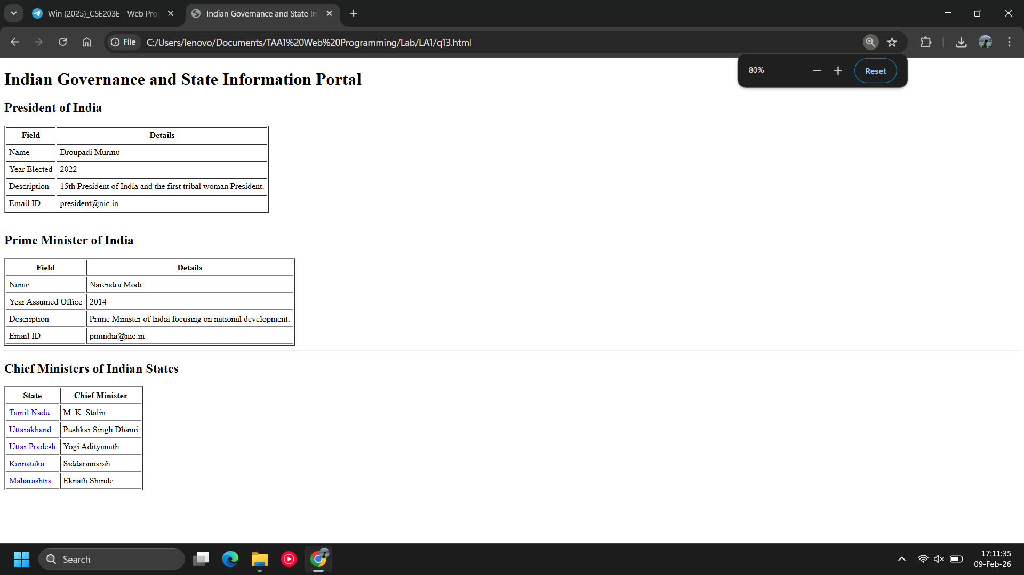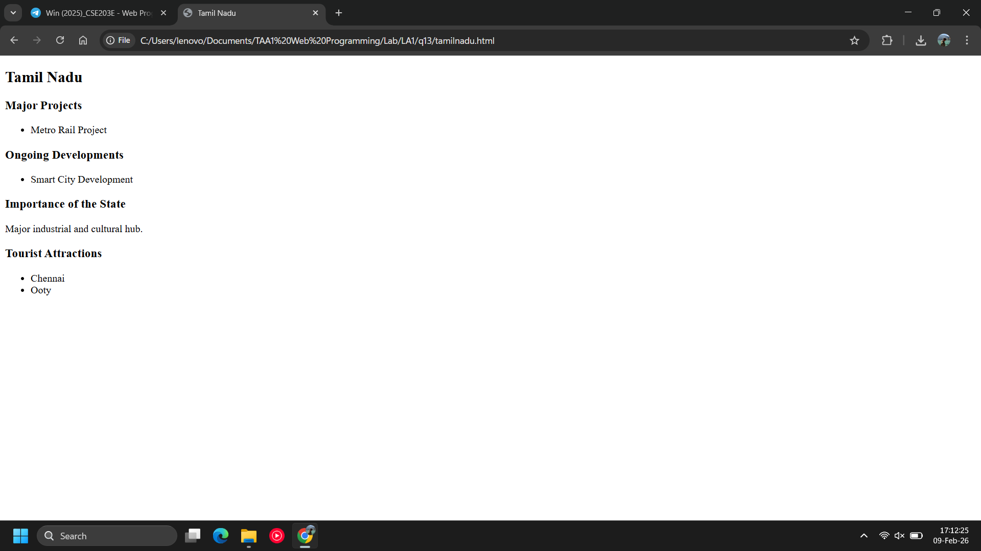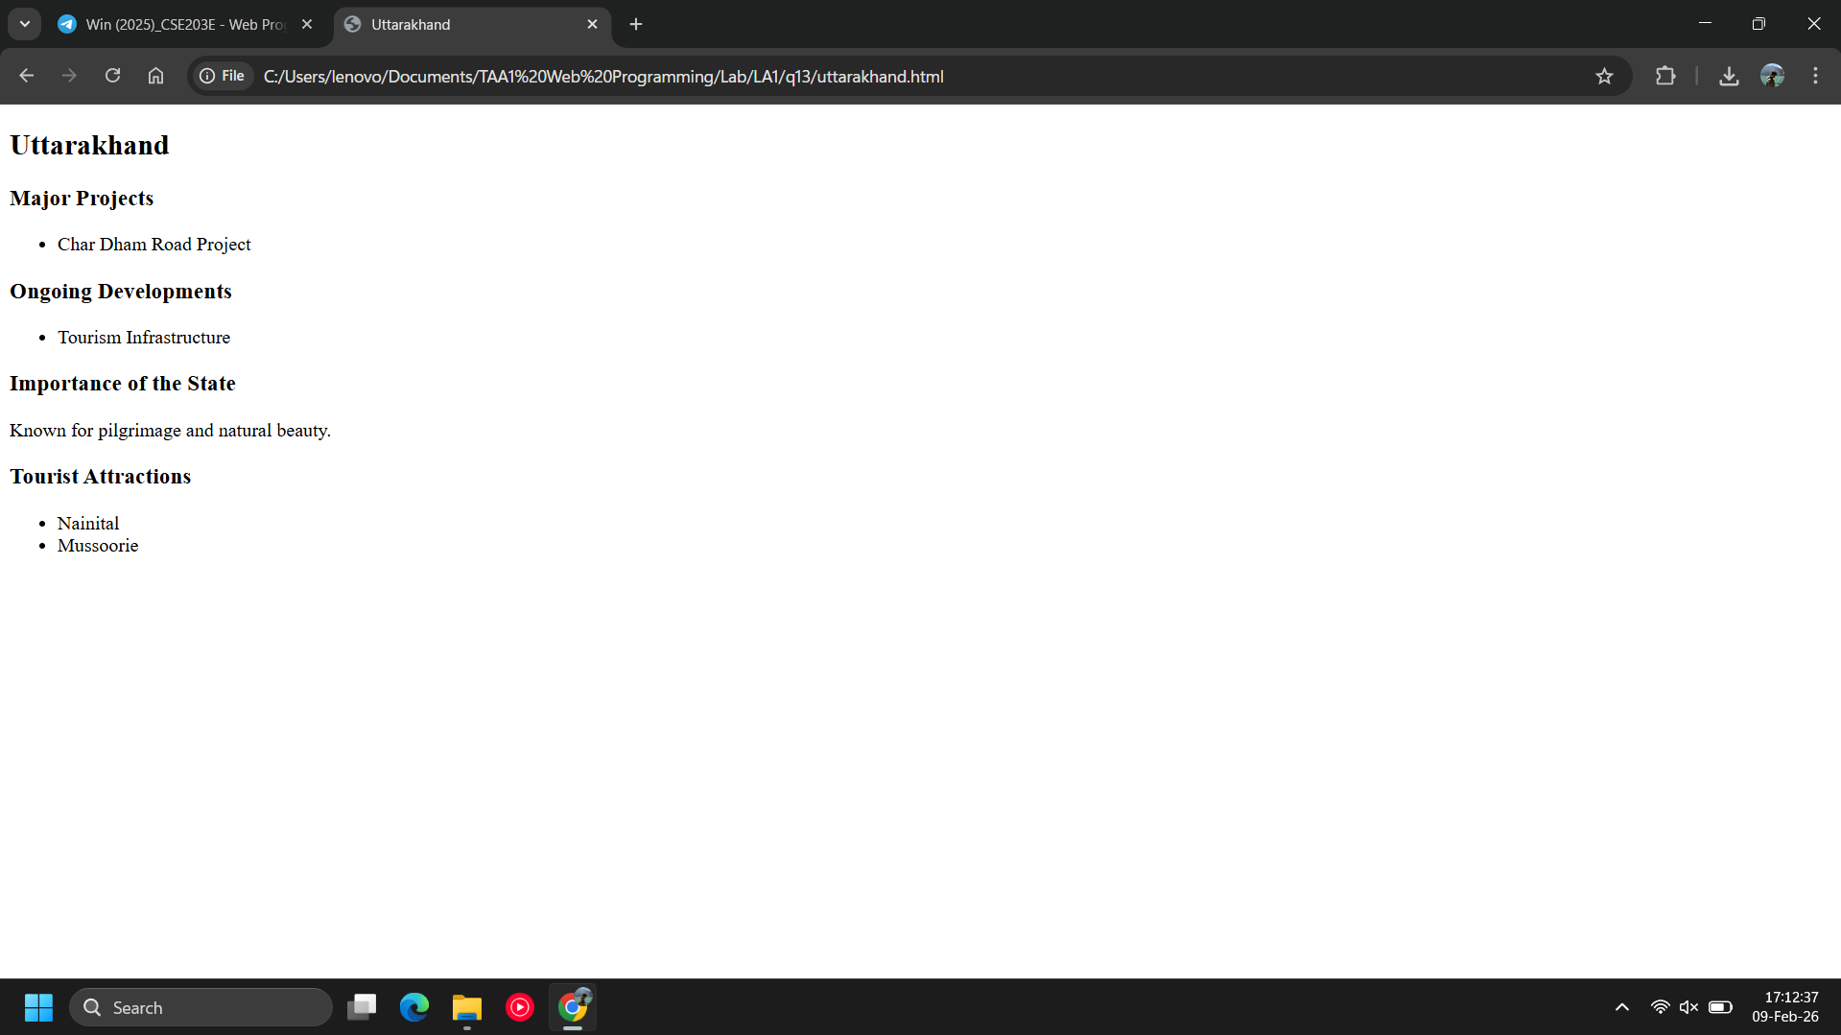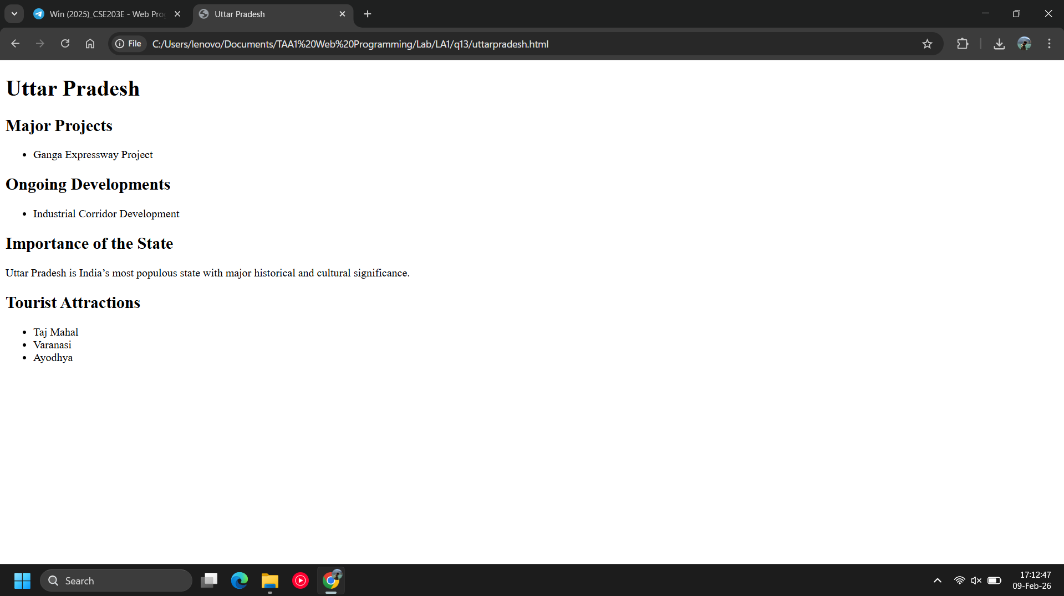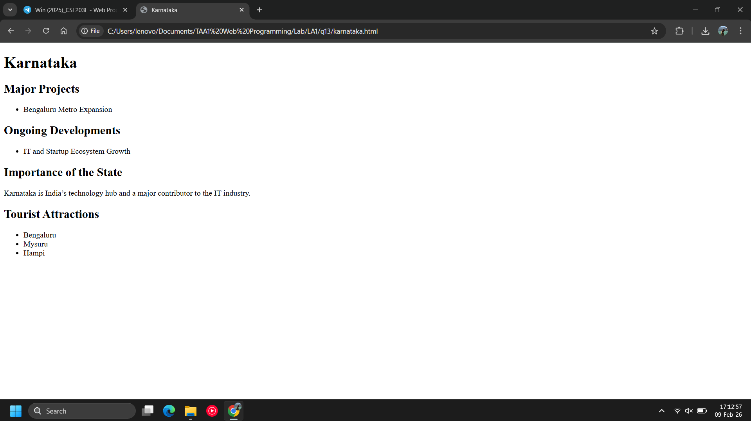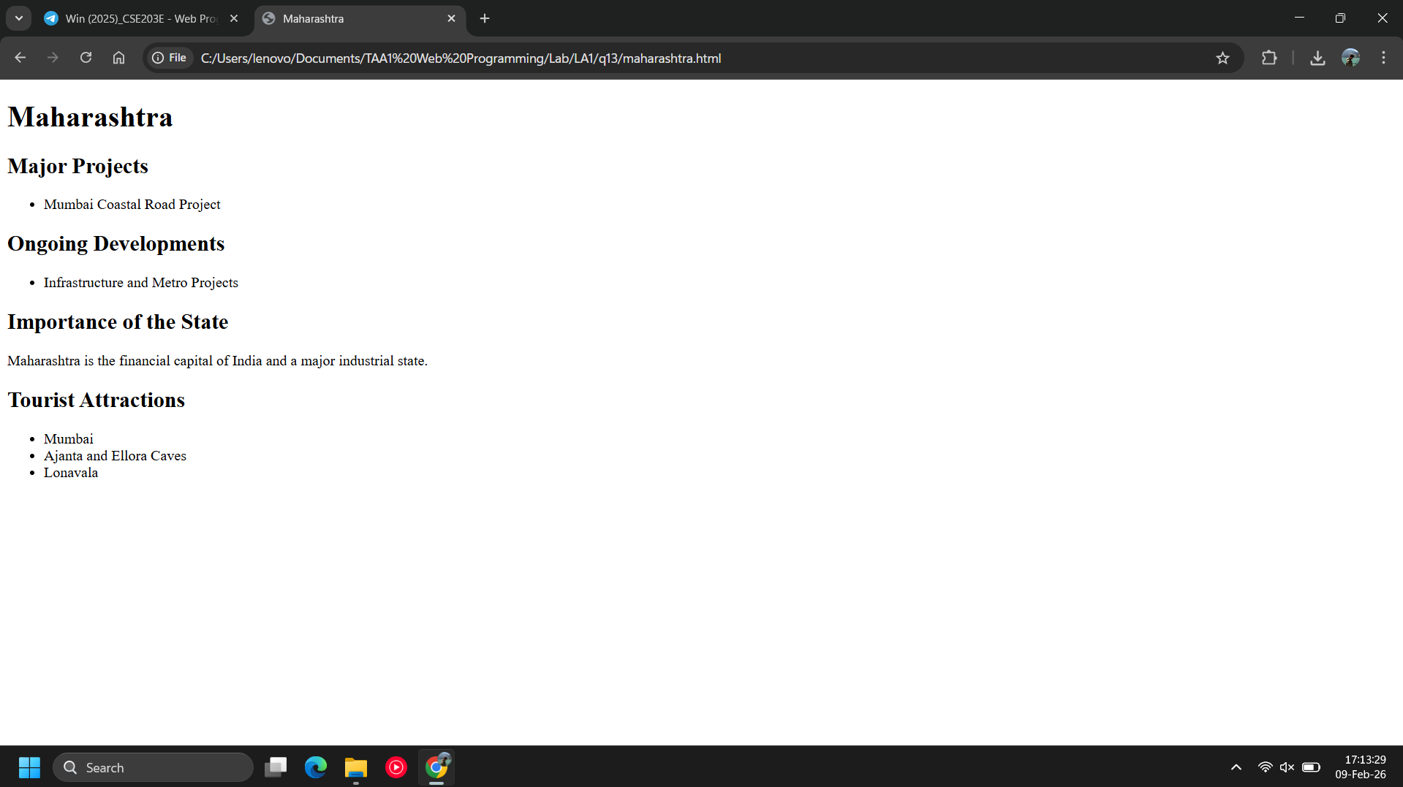
Observations | This program demonstrates a multi-page HTML website for Indian governance information.  Tables are used to display national leadership and state-wise Chief Ministers, and hyperlinks enable navigation to individual state pages.
References

